# ****MaQS**®** Release Notes Version 5.0.0

This document details all changes in this release of the MaQS product.

## CSSD

1. **MaQS Packing**

Separated from old MaQSplus and developed as an individual program for packing trays

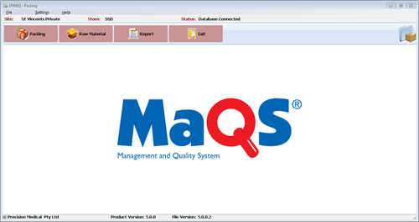 and processed items.

**1.1 Online checklist.**

Allow user using checklist on the screen when pack a tray instead of printing out a

paper checklist.

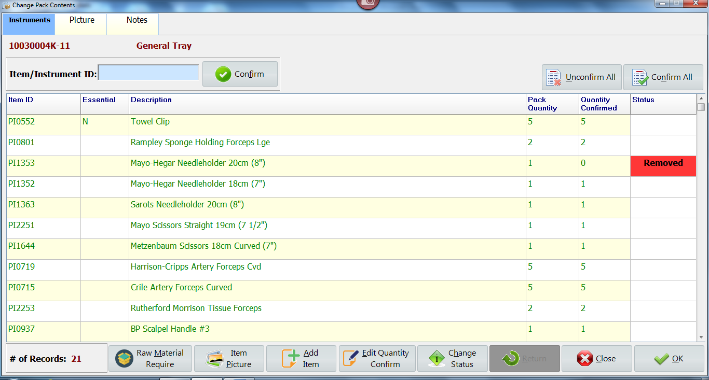

**1.2 Raw Material**

Allow user view, select and manage raw material if required.

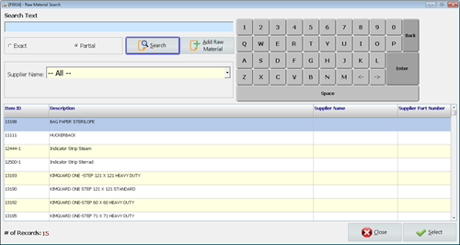

1. **MaQS Decontamination**

**2.1 Record test result**

Ability to record test results as part of the load.

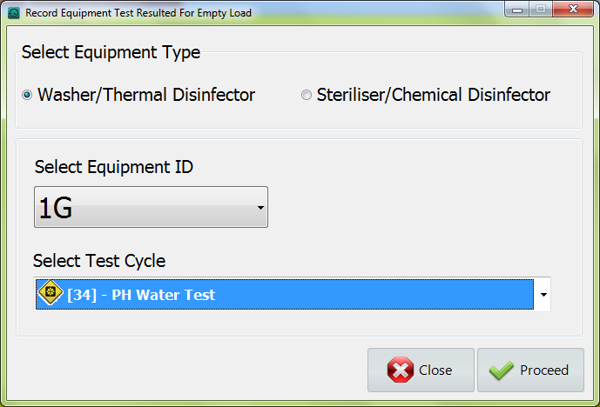

**2.2 Default return reason (Setting in MaQS Admin)**

Allow users manually select return reason when receiving items in decontamination area.



**2.3 Allow Empty Load (Setting in MaQS Client)**

Allow the batch runs an empty load.



1. **MaQS Quality Activity**

Separated from old MaQS Decontamination

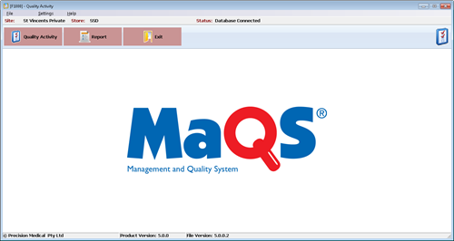

**3.1 Thermal Disinfection**

New process labels are required when performing thermal disinfection in wash

check.

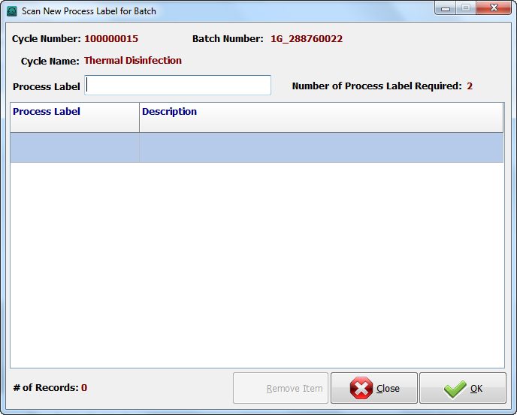

1. **MaQS Client**

**4.1 Interface**

Any equipment that has a data output can now be interfaced into MaQS so check with your

suppliers to confirm the capability. Data records can be saved in different format, such as

word, pdf, html, etc.

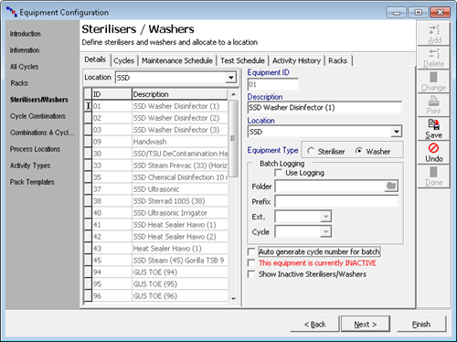

**4.2 Cycle Number**

Cycle number can be generated automatically.



**4.3 Desktop Scanning**

Desktop scanning program is merged into MaQS Client.

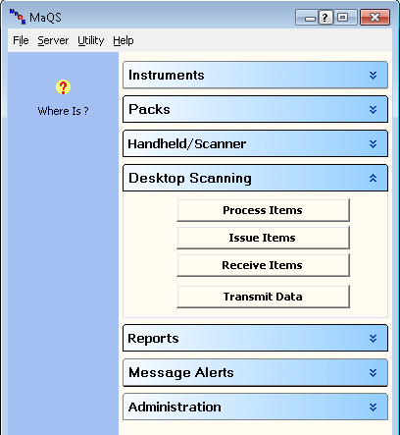

1. **MaQS Launcher**

**5.1 A new look Launcher**

It contains 16 slots for user to create shortcut for their own frequent used

programs.

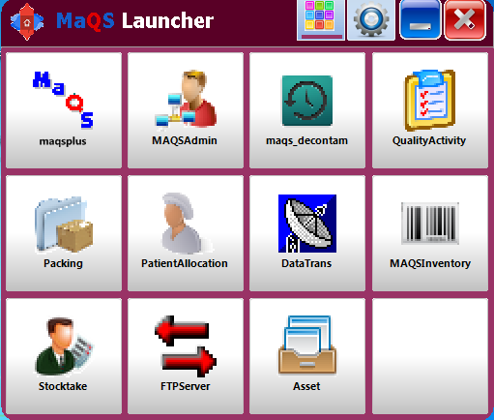

**5.2 Password protected**

Password required when removes shortcuts from launcher.

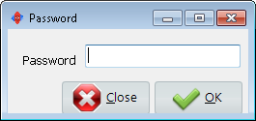

1. **MaQS Admin**

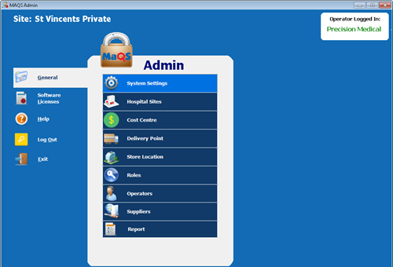

**6.1 Operator table and permissions have been extended to limit the view of screens if**

**required.**

The new Operator screen provides additional options to limit the view and will also show

operators assigned to specific roles

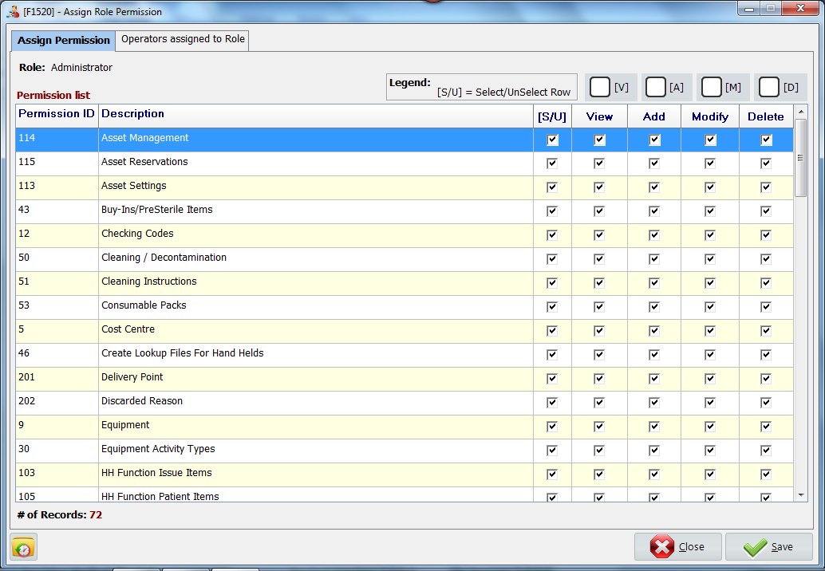

**6.2 Ability to make sites, cost centres, and stores inactive**





**6.3 New delivery point**

Delivery Point information is used for recording the address of where purchase order

delivered to.

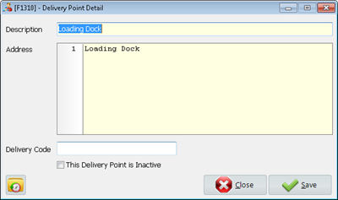

**6.4 Operators that work across sites can have different permissions for each site.**

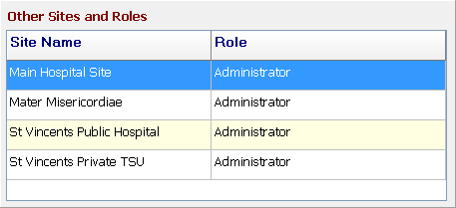

**6.5 Hospital site logo image can be assigned and displayed on the report.**

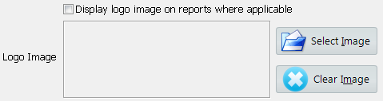

**6.6 Operator Email Address**

In the operator table there is a new field to record staff email address, this is to link in with

the next round of development where MaQS will be able to email reports and send critical

error messages.

